Addressable Minds Viewpoint Messaging

Implementation Overview

July 31, 2013

Overview

Learning House is working with Peerless Education to use leading edge tools and techniques to increase admissions. One of these tools is the Addressable Minds Viewpoint Analyzer (AKA Typing Tool) which is a science-based, international award winning sales tool that immediately identifies a prospective student’s viewpoint on what they consider the most important factors in their choice of a university. Working in conjunction with iNovum, the company that developed this groundbreaking technology, Peerless Education will be implementing this technology with Learning House’s Admission Reps as a tool to help increase sales.

By giving the Admissions Rep the ability to immediately identify a prospective student’s personal viewpoint on what they consider important in their quest for further education, the Rep begins the sales conversation with discussing those positive aspects that are known to apply to that prospect’s viewpoint. This enables the Admissions Rep to connect more rapidly with the prospect resulting in the prospect feeling that, “this person from the school really knows what I want and need”. This results in a more engaging interaction by the Rep, with the ultimate goal to close more sales.

The following is the implementation plan that uses a two stepped approach for the installation and use of the Addressable Minds Viewpoint Analyzer and subsequent Viewpoint Messaging in communication with prospects. It is a rapid two Stepped approach. Step I will initially install the Viewpoint Analyzer and Messaging for use by selected Admission Reps to determine the impact on the sales closing rate. Once this 30 day trial is completed, Step II will see the use of the Viewpoint Analyzer and Viewpoint Messaging expanded to all of Learning House’s Admission reps with an enhanced integration into Learning House’s CRM System.

The following use case diagram identifies the key steps in the Admission Reps existing sales process with a new prospect. Additionally, the use case shows the recommended points in the process to optimize the use of the Viewpoint Analyzer and subsequent messaging with the prospect for Step I – with minimal impact to the existing Learning House CRM System.

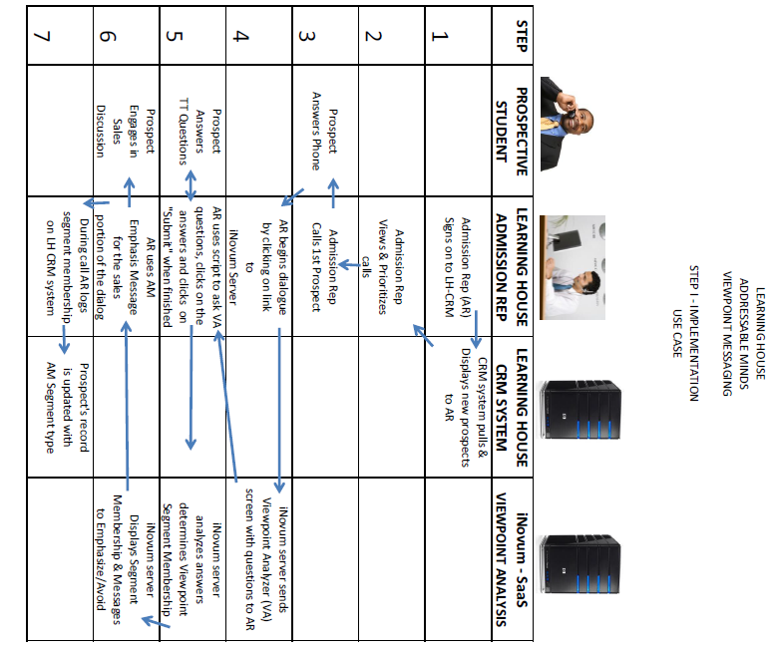

Pre-Step I – Design, build and test (lab) the use of the ViewPoint Analyzer for manual updating of segment membership to a CRM system & the use of the Addressable Minds Messaging in preparation to start Step I. (one - two weeks)

1. ViewPoint Analyzer approval process ( 1 day )

A. Introduce the iframe Link and how it works using unique identifiers

B. Demonstrate live draft version of iFrame Analyzer

C. Update copy/layout per Learning House requirements/suggestions.

D. Finalize the results page with admission reps in mind.

2. Addressable Minds Viewpoint Segment messaging use by admissions reps

A. Review the entire process from point of Analysis to using the messaging

B. Write/define the copy/script for Analysis and for each of the three Viewpoint Segments

C. Dry run scripting for flow with communications to prospects on the phone

3. CRM data fields discussion

1. Review data to collect ( Viewpoint Segment #, Date Typed, Tool Version, Method )
2. Implement CRM form and DB to collect data
3. Test data entry
4. Test run entire process
5. Run process with selected sample prospects on X (TBD) number
6. Review and adjust as necessary and retest
7. After successfully complete move to Step I

Step I – Live pilot use of the ViewPoint Analyzer and use of the Addressable minds messaging with prospects by a limited number of select Admissions Reps (30 days). Manual update of prospect Segment Membership in the CRM is performed in Step I. Step II will see the CRM System automatically update segment membership and is a major change that will occur in Step II.

1. Admission Rep Training
2. Demonstrate the new system to Admission reps.
3. Walk through with admission reps showing use of the Viewpoint Analyzer and subsequent Viewpoint Messages using test prospects. Review and adjust.
4. Go live with Admission reps
5. Monitor Reps Progress
6. Review first day’s usages with admission reps and adjust if needed.
7. Review first week usages with admission reps and adjust if needed.
8. Determine what have we learned so far from typing and review again in one week.
9. Prepare to begin to build the Pre testing work for Step II

Pre-Step II – Design and Build Automated integration of typing results to CRM system

1. ViewPoint Analyzer integration with CRM

A. Review the requirements to automatic insert typing results into CRM system

B. Review CRM data to be AUTOMATED from Step I.

C. Code changes to database if needed

C. Setup new Viewpoint Analyzer to pass results back to CRM system, in addition to the Admission Rep.

D. IT Testing on small sample.

2. Demonstrating the new system to Admission reps who used the Viewpoint System from Step I.

1. Demonstrate the new system to Admission reps.
2. Walk through with admission reps using test prospects and review and adjust.

3. Go live with Admission reps who used the Step I version of the Viewpoint Analyzer

1. Monitor Reps Progress
2. Review first day’s usages with admission reps and adjust if needed.
3. Review first week usages with admission reps and adjust if needed.
4. What have we learned so far from typing and review again in one week.
5. Review results and move to Step II when satisfied

Step II – Automated ViewPoint Analyzer rollout to all Admission Reps

1. Rep Training per Site/School

A. Demonstrate the new system to Admission reps.

B. Walk through with admission reps using test prospects and review and adjust.

2. Go live with Admission reps

3. Monitor Reps Progress

A. Review first day’s usages with admission reps and adjust if needed.

B. Review first week usages with admission reps and adjust if needed.

C. Ongoing monitoring and reporting

Process Management Tracking Chart

|  |  |  |  |
| --- | --- | --- | --- |
| Pre-Step I - Design, build and test | | | |
| Step | Description | Target Date | Completed Date |
| 1 | ViewPoint Analyzer Approval Process |  |  |
| 2 | Addressable Minds Viewpoint Segment messaging use by admissions reps |  |  |
| 3 | CRM Data Fields Discussion |  |  |
| 4 | Test run entire process |  |  |
|  |  |  |  |
| Step I - Live pilot | | | |
| 1 | Rep Training |  |  |
| 2 | GO live with Admission reps |  |  |
| 3 | Monitor Reps Progress |  |  |
| 3A | Review first day’s usages with admission reps and adjust if needed. |  |  |
| 3B | Review first week usages with admission reps and adjust if needed. |  |  |
| 3C | What have we learned so far from typing and review again in one week. |  |  |
| 3D | If things are working as expected Start to build the Pre testing for Step II |  |  |
|  |  |  |  |
| Pre-Step II - Automated integration of typing results to CRM system | | | |
| 1 | ViewPoint Analyzer integration with CRM |  |  |
| 2 | Demonstrating the new system to Admission reps from Step I. |  |  |
| 3 | GO live with Admission reps |  |  |
| 4 | Monitor Reps Progress |  |  |
| 4A | Review first day’s usages with admission reps and adjust if needed. |  |  |
| 4B | Review first week usages with admission reps and adjust if needed. |  |  |
| 4C | What have we learned so far from typing and review again in one week. |  |  |
| 4D | Review results and move to Step II when satisfied |  |  |
|  |  |  |  |
| Step II – Automated ViewPoint Analyzer rollout to all Admission Reps | | | |
| 1 | Rep Training per Site/School |  |  |
| 2 | GO live with Admission reps |  |  |
| 4 | Monitor Reps Progress |  |  |
| 4A | Review first day’s usages with admission reps and adjust if needed. |  |  |
| 4B | Review first week usages with admission reps and adjust if needed. |  |  |
| 4C | Ongoing monitoring and reporting |  |  |
|  |  |  |  |

ViewPoint Analyzer

**A.**  **iFrame Link Configuration**

This is the live base URL to use for Step I manual results collection to the Learning House CRM system. You can take the survey using this link but there will be no Unique ID entered into our system for tracking & audit purposes.

**Link** :** <http://edu.inovumclients.com/iframe.aspx?vender_id=615e0013-7e5c-465e-94db-0dccff2dcca9>

To create the full URL the following Unique ID must be appended.

uid={unigueID} - This is required when used in a self service ViewPoint Analyzer to track/audit results.

To use this variable, append **“&uid=X**” to the Link above.

Where **X** = any characters you prefer to use and length up to 1000 characters.

When this is presented to your admissions rep the link should look like this;

[http://edu.inovumclients.com/iframe.aspx?vender_id=615e0013-7e5c-465e-94db-0dccff2dcca9**&uid=X**](http://edu.inovumclients.com/iframe.aspx?vender_id=615e0013-7e5c-465e-94db-0dccff2dcca9&uid=X)

**NOTE: This link is used for demonstration purposes and will be modified for ease of use by the Admission Reps.

Pre-Step II – Looking Ahead

1. ViewPoint Analyzer integration with CRM automated update of prospect Segment membership

Begin the discussion on automated integration with learning house IT systems after Step I is started.

Determine the programming used and methodology to automated passing segment resulting value to the Prospect’s record in the CRM system

This section will have a detailed update based on the results of findings and recommendations encountered in Step I